Emotive Diction

❤️‍🔥 What is Emotive Diction
# Source: Chatgpt (GPT-4-turbo) at [7/30/2025]
Emotive diction uses emotionally charged words to evoke a strong feeling or reaction from the reader or listener. It's often used in persuasive writing, speeches, poetry, and narratives to stir emotions such as anger, joy, fear, or sadness.

✅ Key Features:
# Source: Chatgpt (GPT-4-turbo) at [7/30/2025]
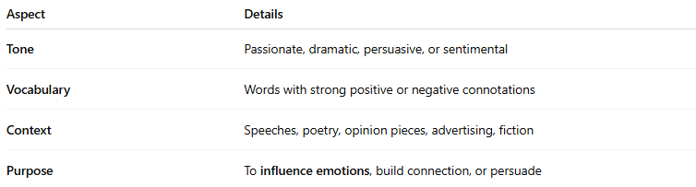
Aspect | Details
Tone | Passionate, dramatic, persuasive, or sentimental
Vocabulary | Words with strong positive or negative connotations
Context | Speeches, poetry, opinion pieces, advertising, fiction
Purpose | To influence emotions, build connection, or persuade

🧠 Examples of Emotive Diction:
# Source: Chatgpt (GPT-4-turbo) at [7/30/2025]
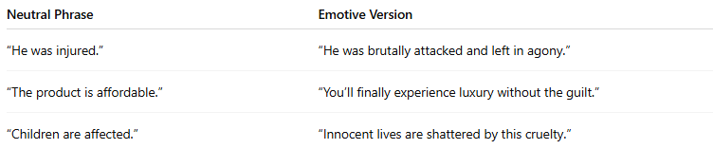
Neutral Phrase | Emotive Version
“He was injured.” | “He was brutally attacked and left in agony.”
“The product is affordable.” | “You’ll finally experience luxury without the guilt.”
“Children are affected.” | “Innocent lives are shattered by this cruelty.”

✍️ Example Sentences Using Emotive Diction:
# Source: Chatgpt (GPT-4-turbo) at [7/30/2025]
- “Her heart shattered into a million pieces when he left.”
- “This reckless policy is a death sentence for our future.”
- “The courageous soldiers laid down their lives for freedom.”

🆚 Emotive Diction vs Neutral Diction:
# Source: Chatgpt (GPT-4-turbo) at [7/30/2025]
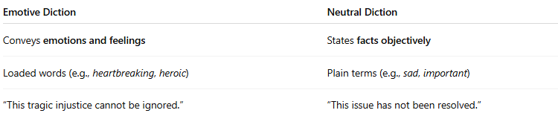
Emotive Diction | Neutral Diction
Conveys emotions and feelings | States facts objectively
Loaded words (e.g., heartbreaking, heroic) | Plain terms (e.g., sad, important)
“This tragic injustice cannot be ignored.” | “This issue has not been resolved.”

🧭 Used In:
# Source: Chatgpt (GPT-4-turbo) at [7/30/2025]
- Speeches and debates
- Poetry and drama
- Advertising and marketing
- Emotional storytelling
- Political rhetoric

